List number 10
Computer System Organization
(You can earn 2 points for each task)

1. Minimize the logical function (if possible). Build a digital circuit that implements this function using only NOR gates.
a) a AND b
b) a XOR b
c) (NOT a) XOR b
d) a XNOR b
e) a NAND b
f) (a+c)(āc)

2. Minimize the logical function (if possible). Build a digital circuit that implements this function using only NAND gates.
a) a OR b
b) a XOR b
c) (NOT a) XOR b
d) a NOR b
e) (a+e)(āē)
f) (āē)+ab

3. Analyze the operation of a digital circuit. Write its truth table or Karnaugh table. Minimize the function and propose a simplified circuit using the canonical DNF or CNF forms.
a)
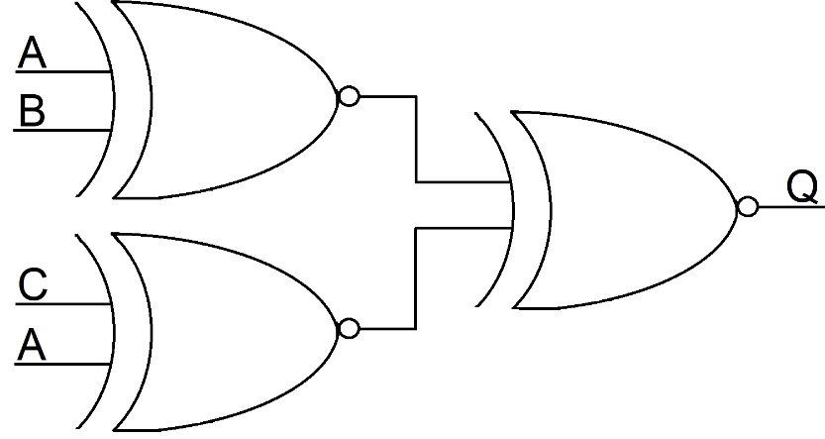
b) a XOR b XOR a
c) (a OR b) AND (a XOR c)
d) (a+e)(āē)+ab

4. Simplify the digital circuit and propose a simplified circuit using the canonical DNF or CNF forms.
a)
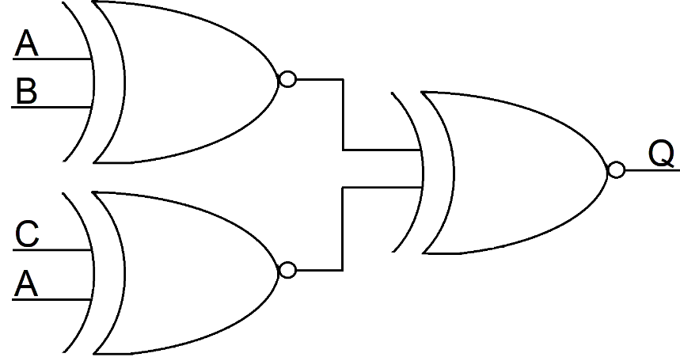

5. Indicate places where logical hazard occurs and describe situations in which it occurs.
a) 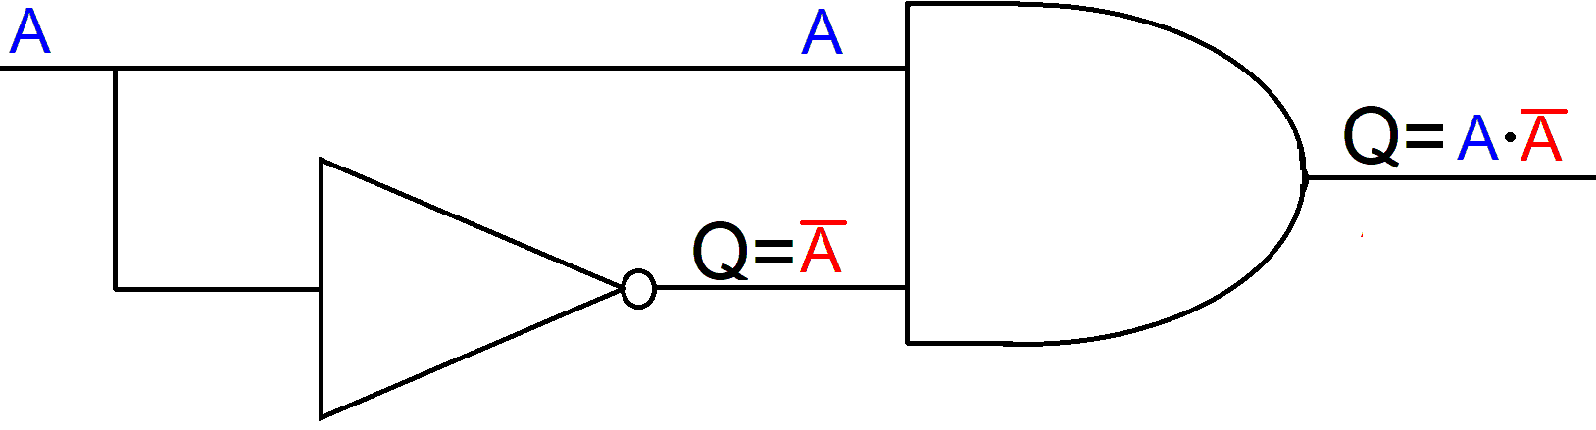

6. Eliminate the occurrence of logical hazard by adding digital elements to the circuit, but without adding a digital buffer.
a)
